How does the web work?

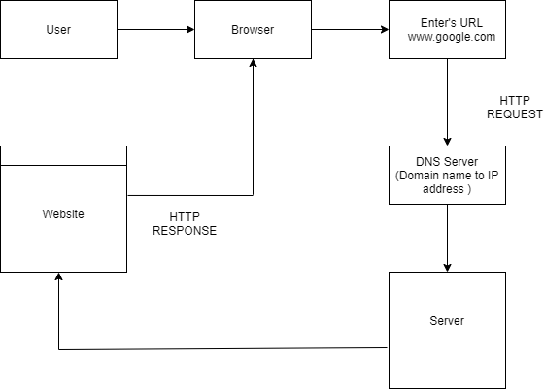

* HTML - Hypertext Markup Language. Used to display data on the web page.
* CSS - Cascading Style Sheets is a style sheet language used for describing the presentation of a document written in a markup language such as HTML.
* JavaScript - JavaScript is a text-based programming language used both on the client-side and server-side that allows you to make web pages interactive. Where HTML and CSS are languages that give structure and style to web pages, JavaScript gives web pages interactive elements that engage a user.
* HTTP/HTTPS - Hypertext Transfer Protocol/Secure
* Server side technologies : Node.js, PHP, Python, etc and their frameworks such as Express.js, Laravel, Django, Flask, etc.

Scaling the web :

Scaling is a term that determines handling of traffic in an efficient way and provides response faster.

Every Time scaling is not recommended to be achieved by increasing the processing hardwares or server. Single server should be optimized to its maximum potential by applying various techniques such as Indexing, efficient coding, Caching, etc to treat and solve various bottlenecks related to Database, Controller, Web server.

Thread Based web servers should be used only when needed. Its usage results in some latency in giving responses to other user requests. Eg. ApacheHTTP

Event Based web servers are more efficient as it serves requests as it gets completed and no unwanted waiting is seen.

If the issue of delayed response is not solved by optimizing a single web server, then hardware upgrade can be done and powerful resources can be added.

If further expansion in the server is needed, Database server can be treated independent and web server and DB server can communicate to fulfill the request. Multiple DB servers can be added which could be connected to the web server by a load balancer which will give the required DB server access and save time in searching. This can be done with a Web server too. Multiple web servers will be connecting through load balancer and processes the request accordingly.

What is meant by ‘Network’ ?

* A network is a group of computers or devices that are interconnected to each other. They share data between them.
* Devices are either connected using cables or wirelessly. Wi-Fi is a commonly used wireless technology. Wired/cabled devices connect to a switch or directly to a router. Wireless devices connect to Access Points (AP).

Network Types :

* SOHO : SOHO is the abbreviation for Small Office/Home Office network. SOHO network is meant for use in small businesses. Most cases, SOHO networks are configured for privately owned businesses or individuals who are self-employed.

SOHO networks are small LANs (Local Area Networks). Typically, SOHO networks consist of less than 10 computers. Network service servers like DNS server, email server, web server etc., are typically configured outside SOHO network.

* LAN ( Local Area Network) : A local area network is a computer network that interconnects computers within a limited area such as a residence, school, laboratory, university campus or office building.
* WAN (Wide Area Network) : A wide area network is a telecommunications network that extends over a large geographic area for the primary purpose of computer networking. A wide-area network (WAN) can also be a collection of local-area networks (LANs) or other networks that communicate with one another.